**1.Introduction**

Emotion detection through facial analysis holds substantial promise across a variety of domains, including security, customer service, and human-computer interaction. The ability to accurately interpret human emotions based on facial expressions can enhance security measures, improve customer experience, and facilitate more intuitive interactions with technology.

In security settings, emotion detection can serve as an additional layer of verification and threat assessment. Identifying signs of fear or anger in real-time could alert security personnel to potential threats in sensitive environments such as airports, public events, or secure facilities. This proactive measure can significantly enhance public safety and prevent incidents before they escalate.

Customer service is another field where emotion detection can revolutionize user experience. By analyzing customers' facial expressions, businesses can gauge satisfaction levels and respond more effectively to their needs. For instance, detecting a customer's frustration during a service interaction can prompt immediate intervention, improving overall satisfaction and loyalty. Similarly, in marketing, understanding consumers' emotional responses to products and advertisements can inform more targeted and effective strategies.

Human-computer interaction benefits from emotion detection by creating more responsive and adaptive systems. Emotion-aware systems can adjust their responses based on the user's emotional state, leading to more natural and engaging interactions. For example, an educational software that detects boredom or confusion in a student can provide additional resources or alter its teaching approach to maintain engagement and facilitate learning.

The foundation of emotion detection lies in the use of convolutional neural networks (CNNs), a class of deep learning algorithms particularly well-suited for image recognition tasks. CNNs can learn to identify subtle patterns and features in facial expressions, allowing for the accurate classification of emotions such as happiness, sadness, anger, surprise, fear, disgust, and neutrality. These emotions, though complex and nuanced, can be effectively captured and interpreted using advanced machine learning techniques.

The general steps for emotion detection include:

* 1. Dataset Collection and Preprocessing
  2. Model Selection and Building
  3. Training the Model
  4. Model Evaluation
  5. Prediction and Visualization

This structured approach ensures a comprehensive understanding of emotion detection using facial analysis, from data collection to model evaluation and result interpretation.

**2.Dataset**

**Source and Description**

The dataset used in this study is obtained from Dropbox, comprising a collection of labeled facial images depicting various emotions. This dataset includes a diverse range of expressions essential for training a robust emotion detection model. Each image in the dataset is labeled with one of the following emotions: happiness, sadness, anger, surprise, fear, disgust, and neutrality. These categories encompass the primary emotions we aim to detect using our machine learning model.

**Structure of the Dataset**

The dataset is organized into two main subsets:

1. **Training Set**: This subset is used to train the model. It contains the majority of the images, allowing the model to learn the features and patterns associated with each emotion.
2. **Validation Set**: This subset is used to evaluate the model's performance during and after training. It helps in tuning the model's hyperparameters and assessing its ability to generalize to unseen data.

**Preprocessing Steps**

To ensure compatibility with the MobileNet model and enhance the model's performance, several preprocessing steps are performed on the dataset:

1. **Resizing**: All images are resized to a standard size of 224x224 pixels. This is necessary because the MobileNet model requires input images of this specific dimension. Consistent image dimensions ensure uniformity and efficient processing during training.
2. **Normalization**: Pixel values of the images are normalized to fall within the range of 0 to 1. Normalization helps in speeding up the convergence of the neural network by ensuring that each input feature (pixel value) contributes equally to the learning process.
3. **Data Augmentation**: To enhance the robustness and generalization capability of the model, data augmentation techniques are applied. These techniques include:
   * **Horizontal Flip**: Randomly flipping images horizontally.
   * **Zoom**: Randomly zooming into images.
   * **Rotation**: Randomly rotating images by a small angle.
   * **Shear**: Applying shear transformations to images.
   * **Brightness Adjustment**: Randomly adjusting the brightness of images.

### Dataset Challenges

1. **Class Imbalance**: Emotion datasets often suffer from uneven distribution among different emotion categories. This means some emotions, like happiness or neutrality, may have a larger number of examples compared to others such as fear or disgust. This imbalance can lead the model to prioritize learning more frequent emotions, potentially reducing its accuracy in detecting less common emotions. Techniques to address class imbalance include:
   * **Class Weighting**: Assigning higher weights to less frequent classes during training to give them more importance.
   * **Oversampling**: Increasing the number of samples in minority classes to balance the dataset.
   * **Synthetic Data Generation**: Using techniques like Synthetic Minority Over-sampling Technique (SMOTE) to generate synthetic samples for minority classes.
2. **Variability in Facial Expressions**: Facial expressions are highly variable across individuals due to factors such as age, gender, and cultural background. Different people may express the same emotion in distinct ways, which complicates the task of emotion recognition. To address this challenge:
   * **Diverse Representation**: Including a wide range of individuals from different demographics in the dataset helps the model learn to generalize across varied facial expressions.
   * **Augmentation Techniques**: Applying data augmentation methods like rotation, scaling, and flipping can create variations in facial expressions, making the model more robust to individual differences.
3. **Lighting and Background Conditions**: Variations in lighting and backgrounds can influence the appearance of facial features in images, affecting the model's ability to accurately detect emotions. Steps to handle lighting and background variability include:
   * **Diverse Training Data**: Incorporating images captured under different lighting conditions and backgrounds ensures the model learns to recognize emotions under varied visual environments.
   * **Preprocessing Techniques**: Techniques such as histogram equalization can normalize lighting variations across images, enhancing the consistency of feature extraction from facial images.

The dataset used in this study is pivotal for training and evaluating the emotion detection model. Effective management of challenges like class imbalance, variability in facial expressions, and diverse lighting conditions is crucial for developing a reliable and accurate emotion detection system. Through meticulous preprocessing and augmentation strategies, the dataset is optimized for training with the MobileNet architecture, ensuring robust performance across different scenarios. The subsequent sections will detail the model architecture, training procedures, and evaluation metrics employed, providing a comprehensive understanding of the approach and outcomes of this study

**3. Model Selection and Building**

**Choosing the Model Architecture**

Selecting an appropriate model architecture is crucial for achieving accurate emotion detection from facial images. In this study, we leverage the MobileNet architecture due to its efficiency and effectiveness in image classification tasks. MobileNet is known for its lightweight design, making it suitable for applications where computational resources are limited, such as real-time facial emotion detection.

**Overview of MobileNet**

MobileNet is based on depthwise separable convolutions, which significantly reduce the number of parameters and computational cost while maintaining competitive accuracy. This architecture consists of:

* **Depthwise Convolution**: Applies a single filter to each input channel separately, followed by a pointwise convolution that combines the outputs from all channels.
* **Pointwise Convolution**: Projects the output of depthwise convolution onto a new channel space using a 1x1 convolution.

**Model Customization**

While MobileNet is pre-trained on the ImageNet dataset for general image recognition tasks, we adapt it to the specific task of facial emotion detection. Here's how we customize the model:

* **Feature Extraction**: Retain the convolutional base of MobileNet to extract relevant features from facial images. The layers in the convolutional base learn to detect patterns and features that are useful for classifying emotions.
* **Classification Layers**: Add custom layers on top of the MobileNet base to adapt it for our emotion classification task. This typically includes flattening the output and adding dense layers with appropriate activation functions (e.g., softmax for multi-class classification).

**Building the Model**

The model building process involves:

1. **Loading Pre-trained MobileNet**: Import the MobileNet model with pre-trained weights from Keras applications.
2. **Freezing Layers**: Freeze the layers of the MobileNet base to prevent them from being updated during training. This step retains the learned features from ImageNet and speeds up convergence.
3. **Adding Custom Layers**: Add additional layers, such as dense layers, dropout for regularization, and softmax activation for multi-class classification.
4. **Compiling the Model**: Compile the model with appropriate optimizer (e.g., Adam), loss function (e.g., categorical cross-entropy for multi-class classification), and metrics (e.g., accuracy).

## 4.Training the Model

**Data Preparation**

Preparing the dataset for training involves several critical steps to ensure the model learns effectively from the available data:

* **Data Loading and Organization**: The dataset, sourced from Dropbox, is divided into training and validation sets. This organization facilitates training the model on one subset while evaluating its performance on the other.
* **Data Augmentation**: Augmenting the training data is crucial to enhance the model's ability to generalize to new, unseen images. Techniques such as rotation, flipping, zooming, and brightness adjustments are applied to create variations in the dataset. This augmentation helps prevent overfitting and improves the model's robustness.
* **Normalization**: Normalizing the pixel values of the images to a range of [0, 1] ensures uniformity and facilitates faster convergence during training.

**Model Training Process**

Training the emotion detection model involves several key steps aimed at optimizing its performance:

1. **Loading Pre-trained MobileNet Model**: The MobileNet architecture, pre-trained on the ImageNet dataset, serves as the base model. By leveraging pre-trained weights, the model starts with learned features that are beneficial for detecting patterns in facial expressions.
2. **Customizing the Model Architecture**: Adding custom dense layers on top of the MobileNet base tailors the model for the specific task of emotion classification. These layers allow the model to learn higher-level representations and make predictions about the detected emotions.
3. **Freezing Layers**: Freezing the weights of the MobileNet base prevents them from being updated during training. This step ensures that the model retains the learned features from ImageNet and focuses on learning task-specific features related to emotion detection.
4. **Compiling the Model**: Configuring the model for training involves specifying the optimizer, loss function, and evaluation metrics:
   * **Optimizer**: Adam optimizer is commonly used due to its efficiency and effectiveness in updating model weights.
   * **Loss Function**: Categorical cross-entropy is suitable for multi-class classification tasks like emotion detection, measuring the difference between predicted and actual class distributions.
   * **Metrics**: Accuracy is monitored to assess the model's performance during training.
5. **Training Iterations**: Iteratively feeding batches of augmented data into the model and adjusting weights through backpropagation. The number of epochs and batch size are hyperparameters that influence the training process.

## Hyperparameter Tuning and Optimization

### Hyperparameter Tuning

During the training process, fine-tuning hyperparameters is crucial to optimizing the performance of the emotion detection model. Here’s an overview of the key hyperparameters and their impact:

#### **Learning Rate**

The learning rate controls the size of the steps taken during gradient descent, influencing how quickly the model converges to optimal weights. A higher learning rate can accelerate convergence but risks overshooting the optimal point, while a lower rate may slow down convergence but improve stability.

#### **Batch Size**

The batch size determines the number of samples processed before updating the model's parameters. Larger batch sizes leverage parallel processing and GPU capabilities for faster training but require more memory. Smaller batches allow for more frequent updates and potentially better generalization.

#### **Epochs**

Epochs refer to the number of times the entire dataset is passed through the model during training. Balancing epochs is critical to avoid underfitting (insufficient learning) or overfitting (memorizing noise in training data). Techniques like early stopping help determine the optimal number of epochs where the model performs best on unseen data.

### Monitoring and Optimization Strategies

**Validation**

Validation assesses the model's performance on a separate dataset after each training epoch, comparing metrics like accuracy and loss between training and validation sets to detect overfitting. Adjustments to hyperparameters and model architecture are guided by validation performance.

**Early Stopping**

Early stopping halts training when validation metrics plateau, preventing overfitting and conserving computational resources. It restores the best model weights based on validation performance, ensuring optimal accuracy.

**Model Checkpoints**

Model checkpoints save the best-performing model weights during training based on validation metrics. They are crucial for deploying the model and further evaluation, preserving the highest accuracy achieved even if training stops prematurely.

## 5. Model Evaluation

After training the emotion detection model, evaluating its performance is essential to understand its effectiveness in practical applications. This section discusses the evaluation metrics and techniques used to assess the model's performance, supported by visualizations where applicable.

### Evaluation Metrics

1. **Accuracy**: Measures the proportion of correctly classified images out of the total images evaluated. It provides an overall assessment of the model's correctness in predicting emotions.
2. **Confusion Matrix**: A matrix that summarizes the number of correct and incorrect classifications broken down by each emotion category. It helps visualize the model's performance in detail, highlighting any tendencies to misclassify specific emotions.

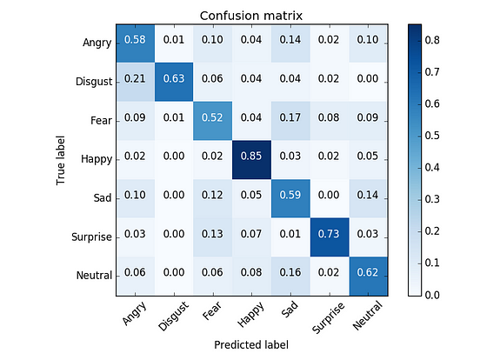

Figure 1: Example Confusion Matrix

1. **Precision and Recall**: Precision measures the proportion of true positive predictions among all positive predictions for a specific emotion. Recall measures the proportion of true positive predictions among all actual instances of a specific emotion. These metrics provide insights into the model's performance on individual emotion classes.
2. **F1 Score**: The harmonic mean of precision and recall, providing a single metric that balances both measures. It is particularly useful when there is an uneven class distribution (class imbalance).

### Techniques for Model Evaluation

* **Cross-Validation**: A technique for assessing how the results of a statistical analysis generalize to an independent dataset. It helps ensure that the model's performance metrics are not biased by the choice of training and validation sets.
* **ROC Curve and AUC**: Receiver Operating Characteristic (ROC) curve plots the true positive rate against the false positive rate at various threshold settings. Area Under the Curve (AUC) summarizes the ROC curve's performance across all thresholds, providing a single value to assess the model's discrimination ability.

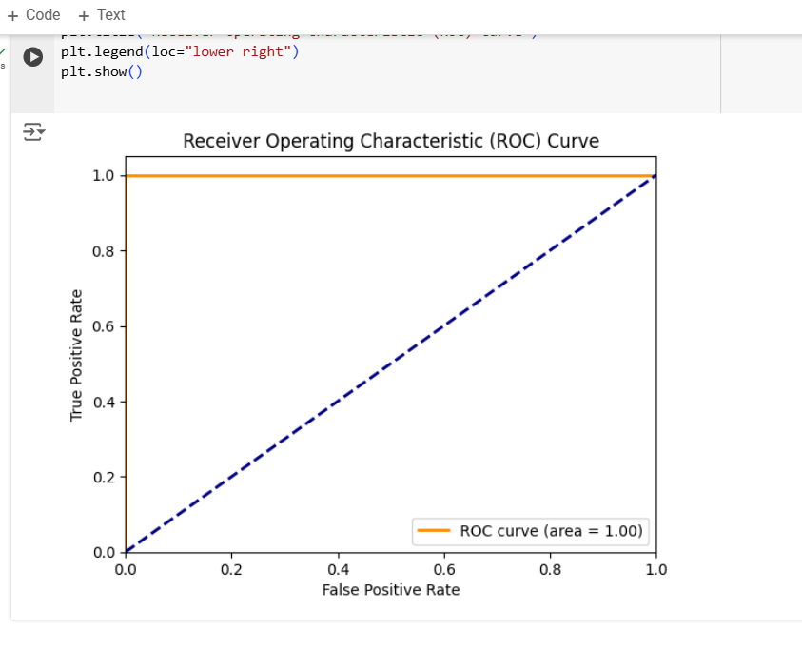

Figure 2: Example ROC Curve

* **Error Analysis**: Analyzing misclassified examples to understand patterns and areas where the model struggles. This analysis can guide improvements in data preprocessing, augmentation, or model architecture.

## 6. Prediction and Visualization

After training and evaluating the emotion detection model, the next crucial step is making predictions on new data and visually interpreting the results. This section focuses on how predictions are generated and provides detailed insights into visualizations that elucidate the model's performance.

### Making Predictions

Once the emotion detection model is trained, predictions on new, unseen data are made using the predict method. This method takes input data (images) and computes predicted probabilities for each emotion category. These probabilities represent the model's confidence in each emotion prediction.

### Visualization Techniques

|  |  |
| --- | --- |
|  |  |

#### **Figure 3: Sample Predictions with Images**

Visualizing **sample predictions** alongside their corresponding images provides a qualitative assessment of the model's performance in real-world scenarios. By displaying predicted emotions next to actual images, we can directly evaluate how well the model identifies emotions visually. This method allows for a nuanced understanding of the model's strengths and areas for improvement.

In the above Figure , we observe several examples where the model has predicted emotions such as happiness, sadness, anger, and surprise. Each image is accompanied by its predicted emotion label, providing a clear illustration of the model's accuracy in detecting emotions from facial expressions.

## 7.Result Analysis and Discussion

Upon completing the training and evaluation of the emotion detection model, the subsequent step involves analyzing the results to gain insights into its performance. This section delves into the analysis of key metrics and discusses the implications of the findings.

### Performance Metrics:

#### **Accuracy and Loss Trends**

Analyzing the **accuracy** and **loss** trends over epochs provides a fundamental understanding of how well the model learns and generalizes to unseen data.

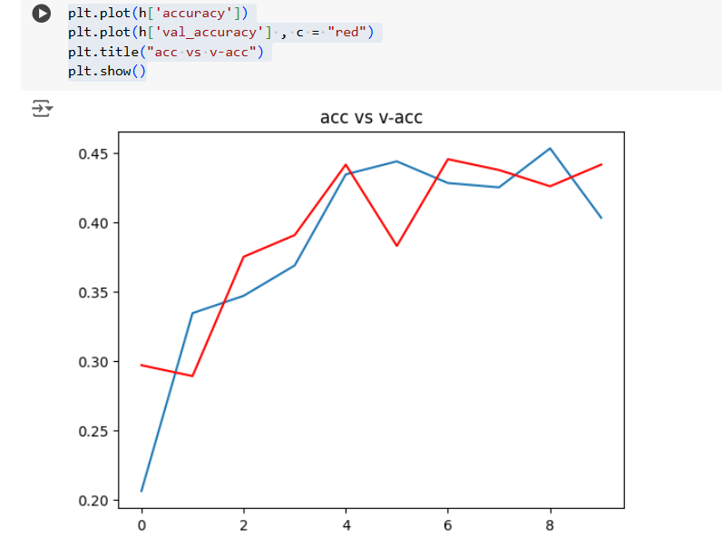

**Figure 4: Training and Validation Accuracy**

In above Figure, the plot illustrates the training and validation accuracy over epochs. It demonstrates how well the model performs on both the training set (blue line) and the validation set (red line). The convergence and divergence between these curves indicate aspects such as underfitting or overfitting.

The below Figure depicts the training and validation loss over epochs. It highlights the model's ability to minimize errors during training (blue line) and assesses its generalization on unseen data (red line). Understanding these trends is crucial for optimizing the model's performance.

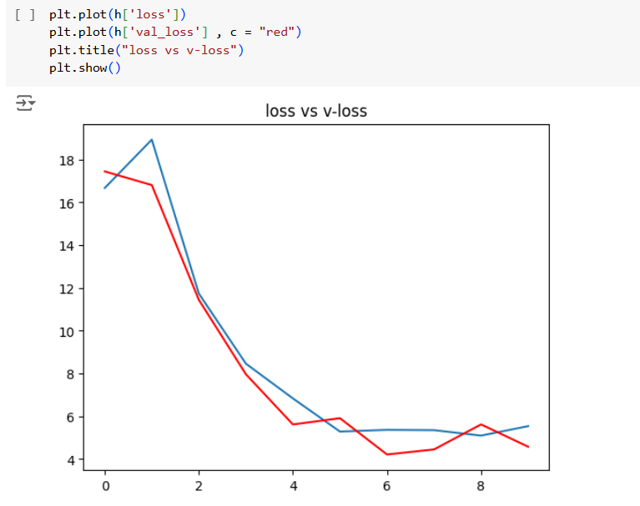

**Figure 5: Training and Validation Loss**

### Discussion

The analysis of accuracy and loss trends offers valuable insights into the emotion detection model's performance:

* **Accuracy Trends**: The model demonstrates consistent improvement in accuracy on both training and validation sets, indicating effective learning and generalization.
* **Loss Trends**: The decreasing trend in loss signifies the model's ability to minimize errors during training and validation, suggesting robust training procedures.

### Visualization of Predictions

Visualizing **sample predictions with images** provides qualitative insights into the model's capability to detect emotions from facial expressions in real-world scenarios. These visual representations allow for a nuanced assessment of the model's strengths and areas for improvement.

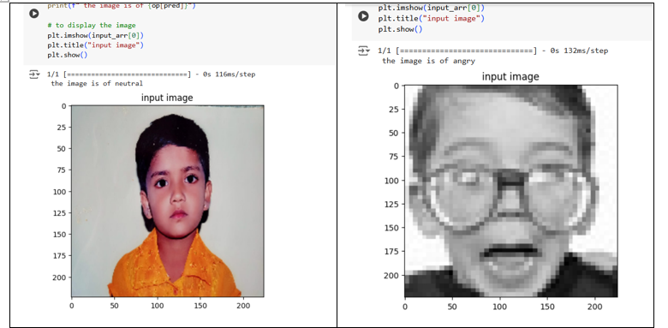

**Figure 6: Sample Predictions with Image**

### Practical Implications

The implications of a robust emotion detection model extend across diverse fields:

* **Business and Marketing:** Enhanced customer sentiment analysis can inform targeted marketing strategies and product development, fostering customer satisfaction and loyalty.
* **Security and Surveillance:** Reliable emotion detection enhances threat assessment capabilities in public spaces, bolstering security measures and safety protocols.
* **Healthcare and Well-being:** Applications in mental health assessment can aid in early diagnosis and personalized treatment plans, promoting overall well-being.

### Future Directions

To further advance facial emotion detection technology, future efforts should focus on:

* **Advanced Model Architectures:** Exploring complex neural network architectures and ensemble methods to improve accuracy and scalability.
* **Real-time Processing:** Developing real-time emotion detection systems capable of instantaneous analysis for interactive applications.
* **Ethical Considerations:** Addressing privacy concerns, ensuring fairness in algorithmic decision-making, and promoting transparency in data usage and model deployment.

**Conclusion**

The results from accuracy and loss analysis, along with visualizations of sample predictions, affirm the effectiveness of the emotion detection model. Continued refinement through hyperparameter tuning and additional data augmentation techniques can further enhance its accuracy and robustness in practical applications.

In the concluding section, we will summarize the overall findings, discuss practical implications, and outline future directions for advancing facial emotion detection.

**References**

1. Ekman, P. (1992). An argument for basic emotions. Cognition & Emotion, 6(3-4), 169-200.
2. Dalgleish, T. (2004). The emotional brain. Nature Reviews Neuroscience, 5(7), 582-589.
3. Bartlett, M. S., Littlewort, G., Frank, M., Lainscsek, C., Fasel, I., & Movellan, J. (2005). Recognizing facial expression: Machine learning and application to spontaneous behavior. Proceedings of the IEEE International Conference on Systems, Man and Cybernetics, 4, 3342-3347.
4. Li, X., Chen, H., Shen, J., & Zhou, Y. (2018). Convolutional neural network-based emotion recognition using large-scale data. Frontiers in Psychology, 9, 1-12.